1030_PTR Enrollment initiated by EV for Combo customer
Contract No. 4013670271
Material No. 88000105
Serial No. 29101107
Equipment No. 100005155092
Contract Account. 100047520844
Functional Location. 6002276609

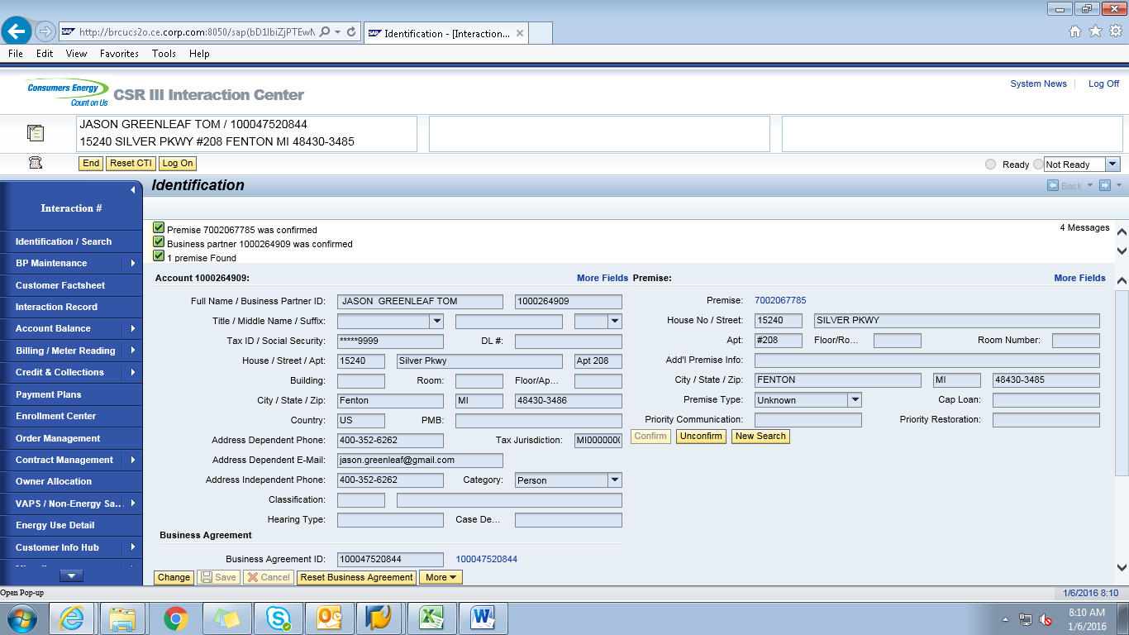
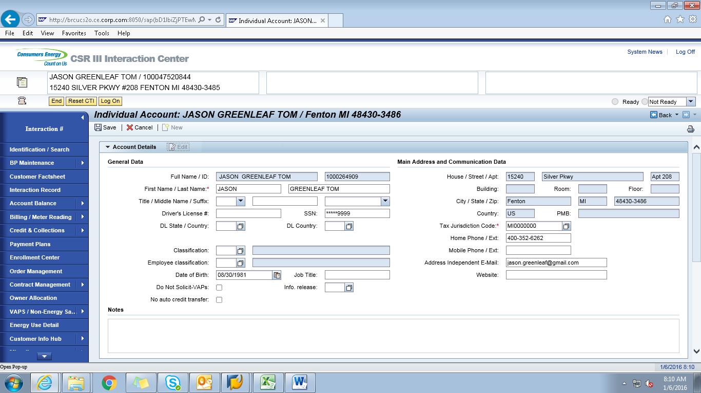
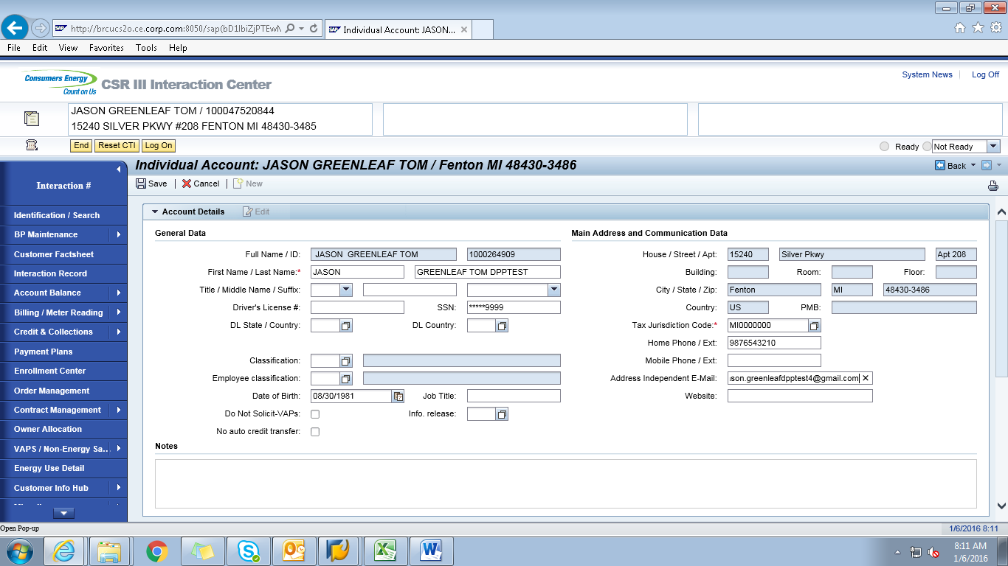
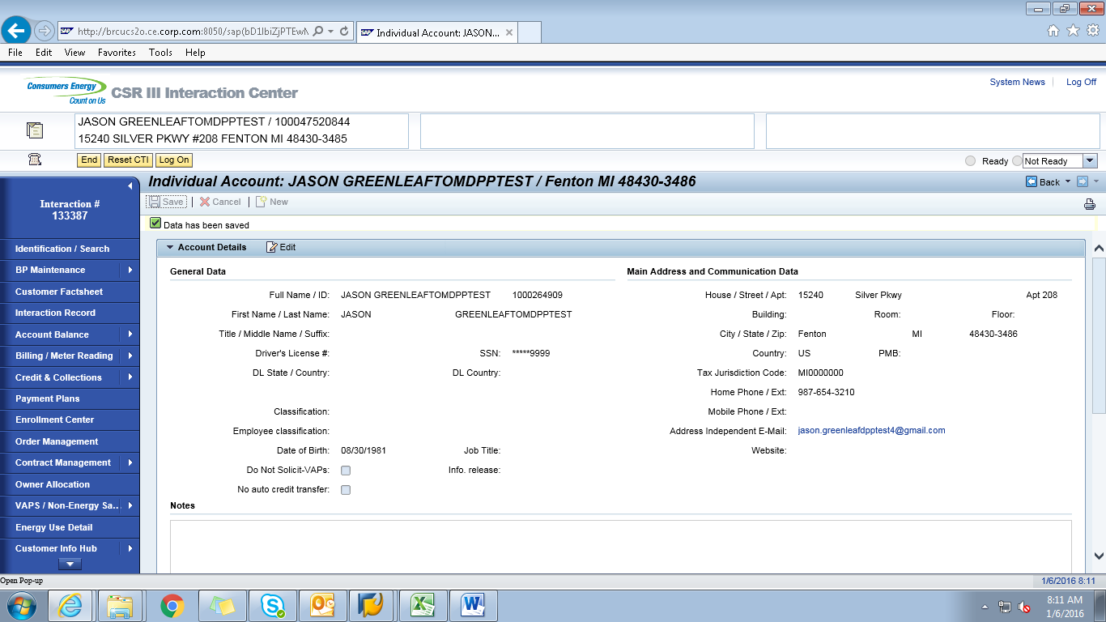
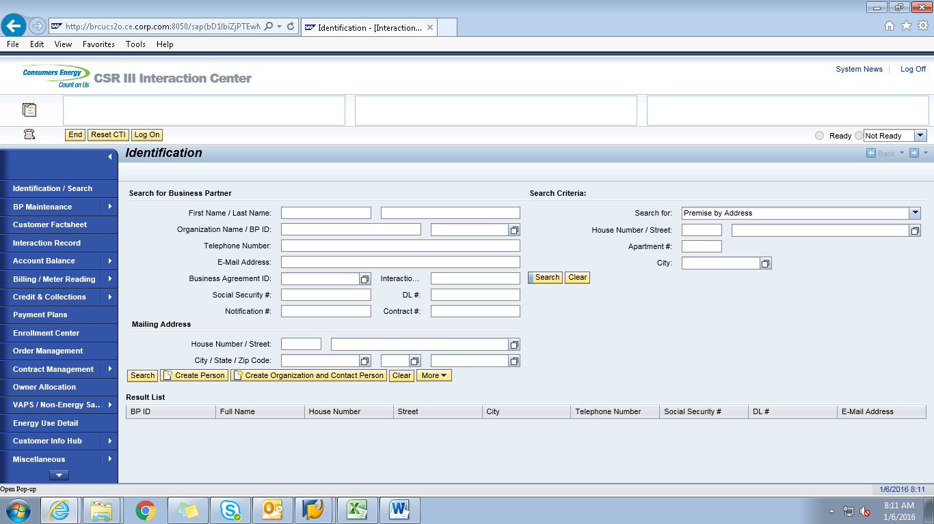
ECC
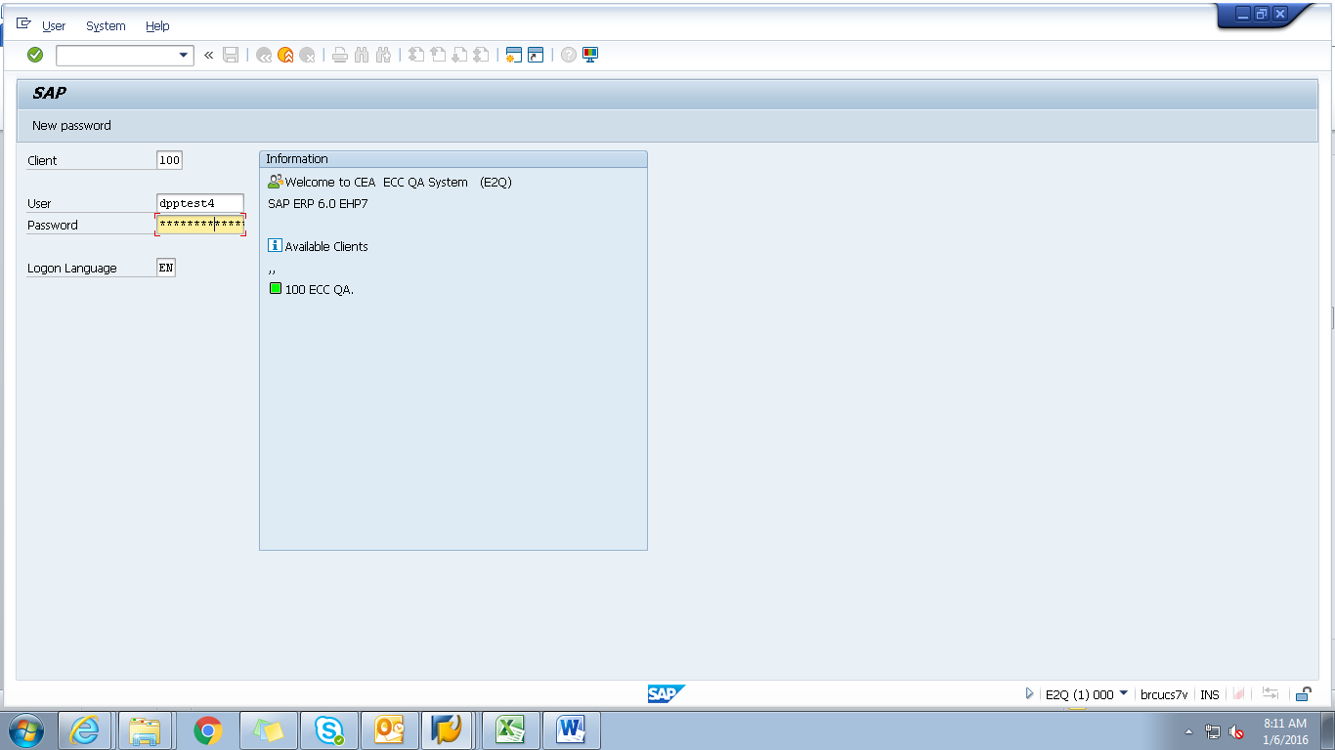
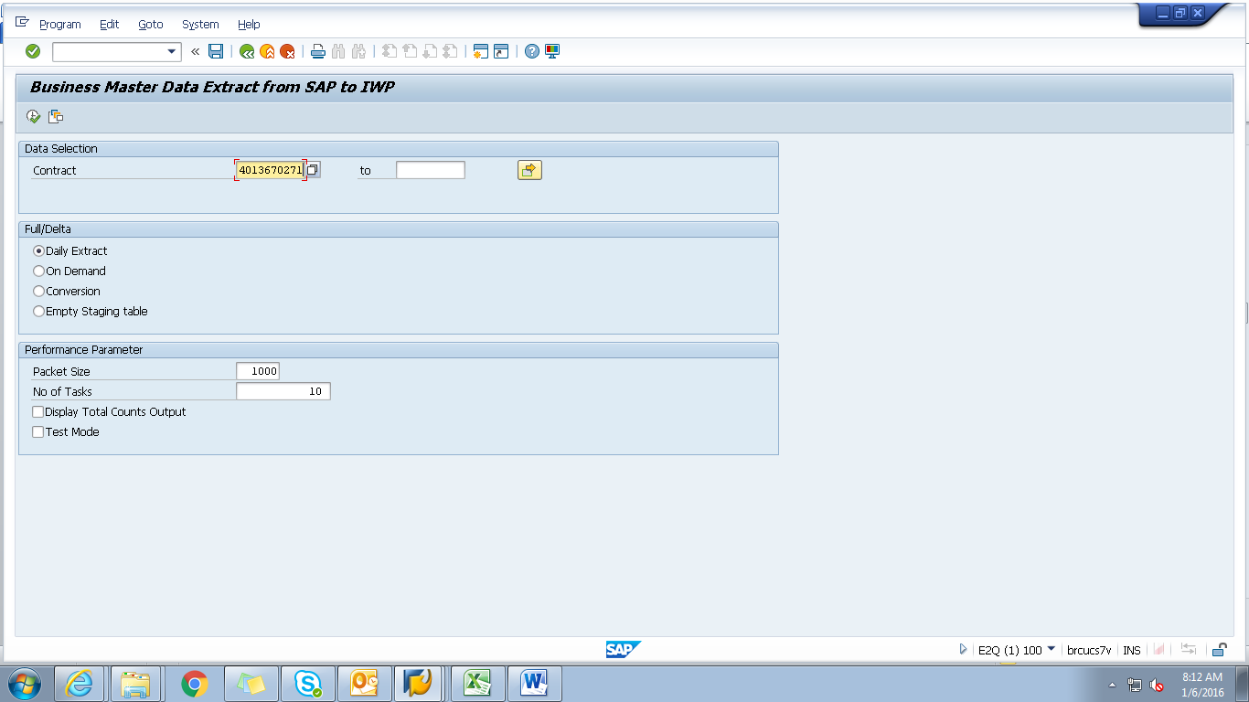
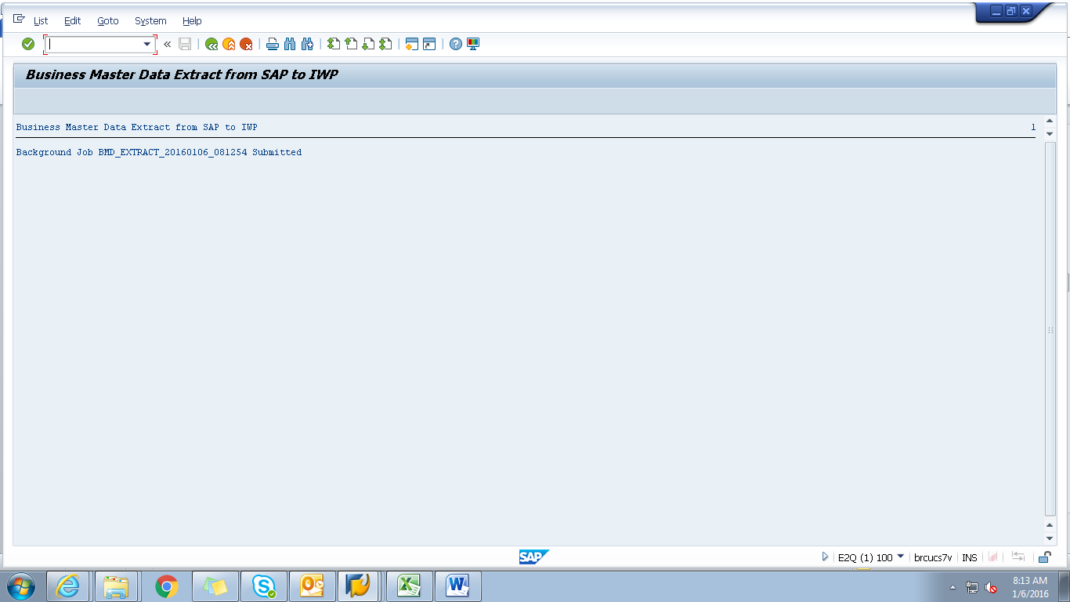
Obj tracking
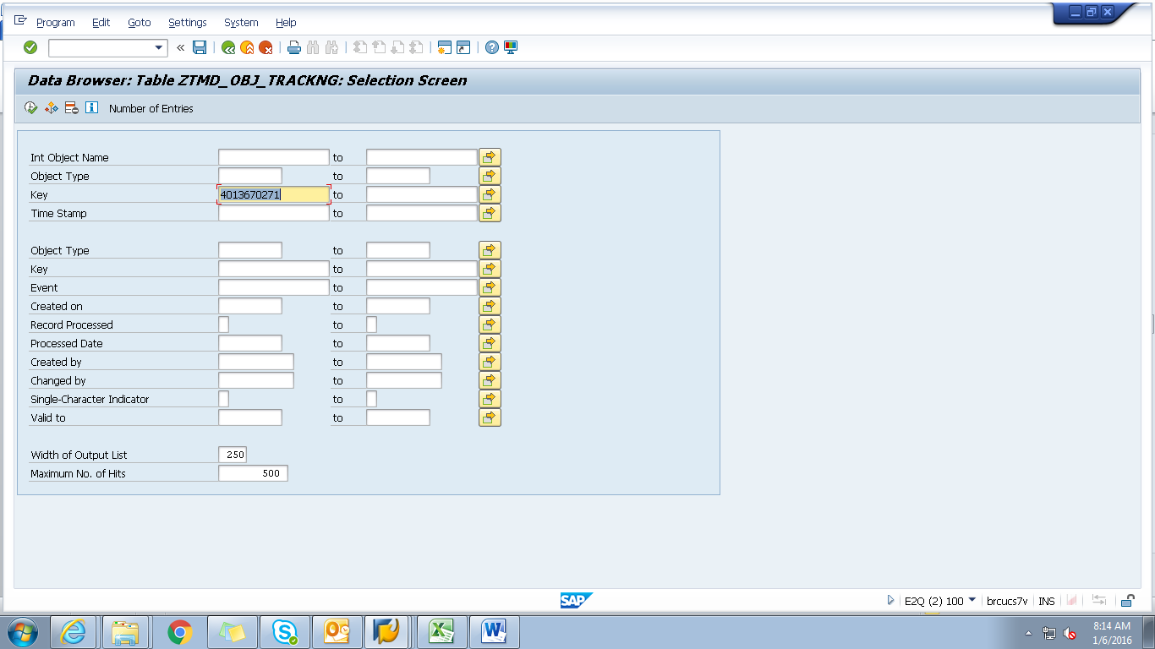
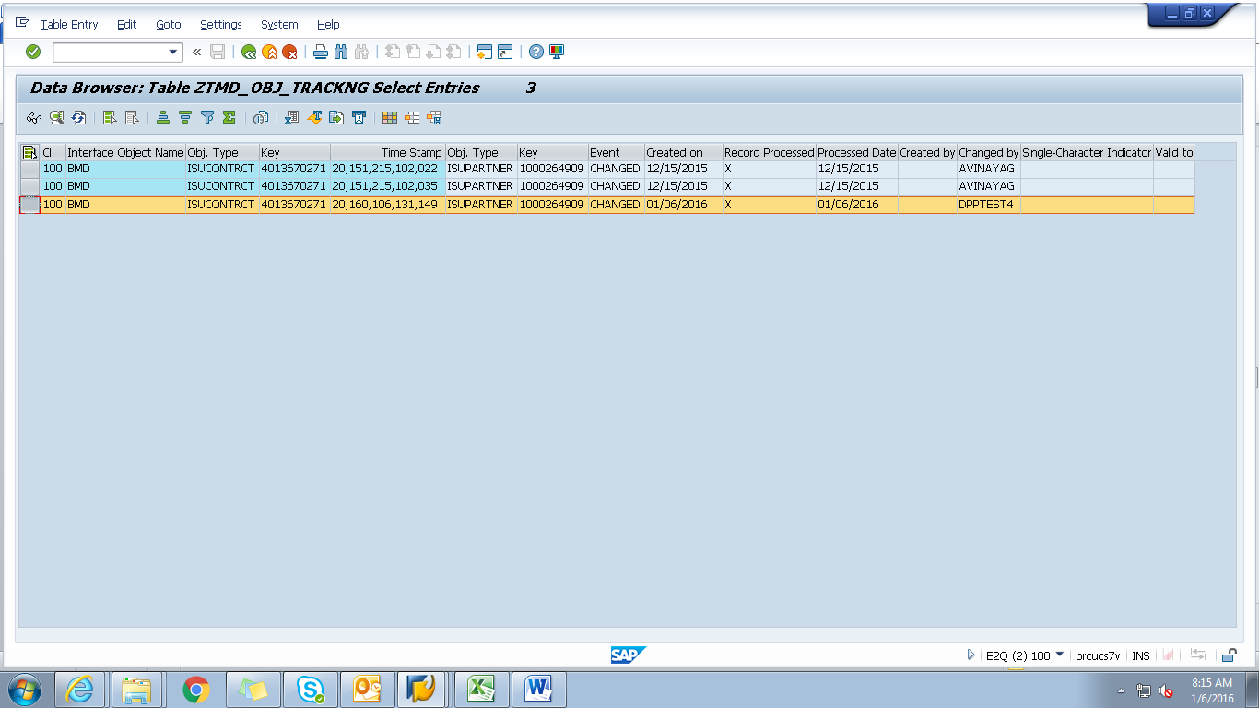
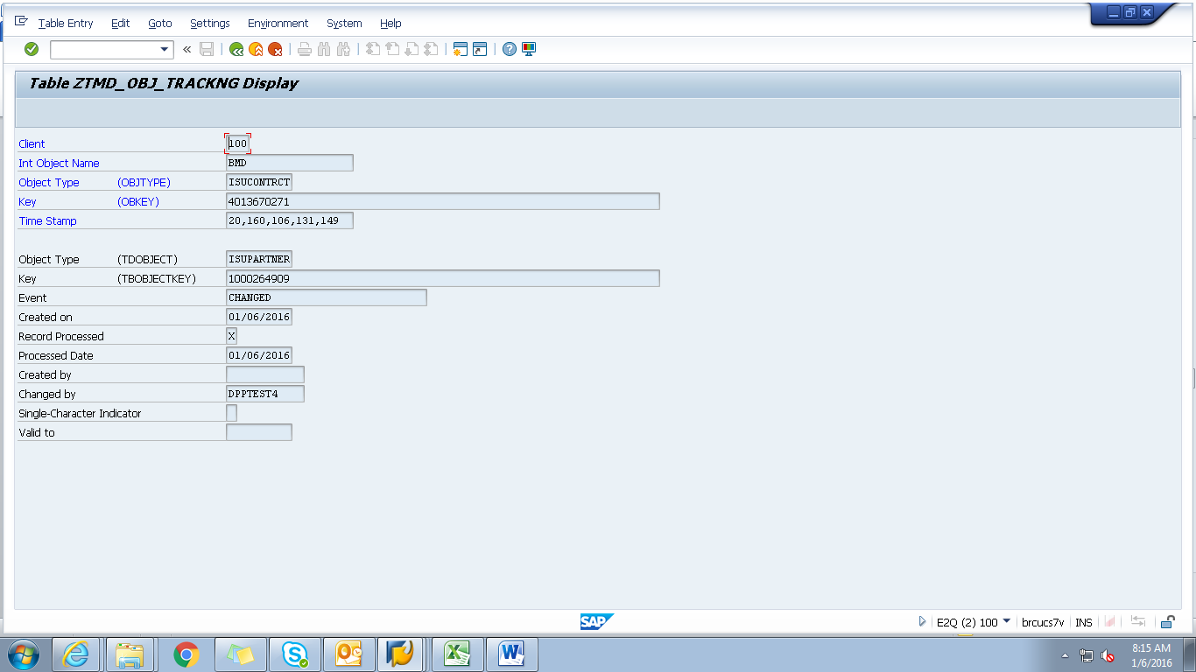
Spool
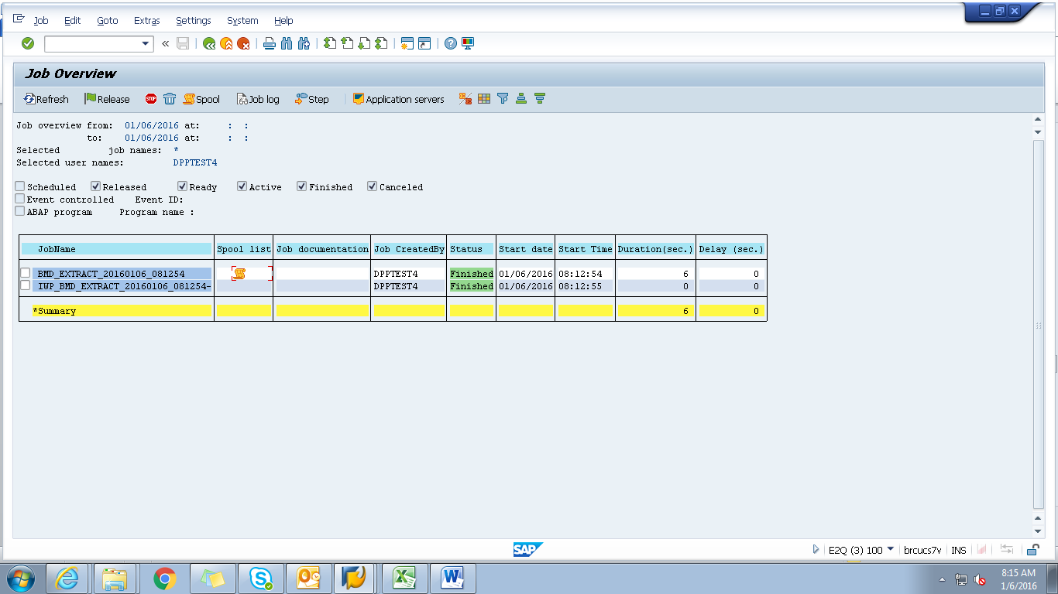
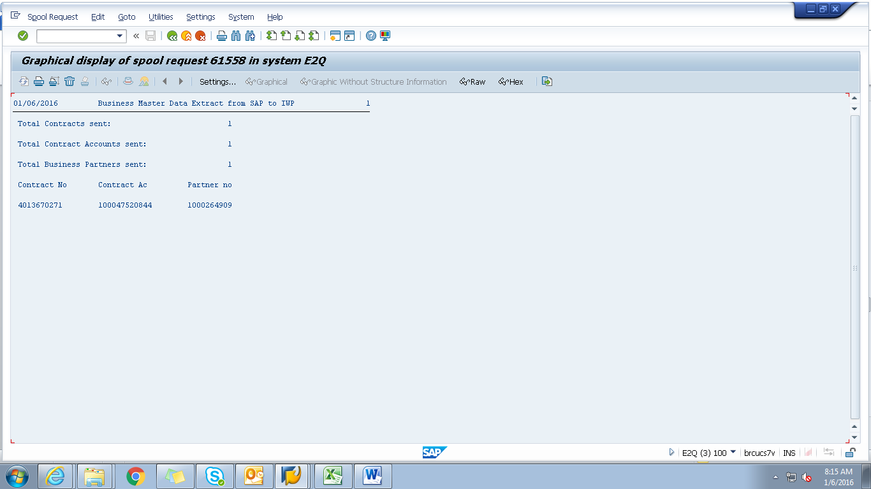
Payload
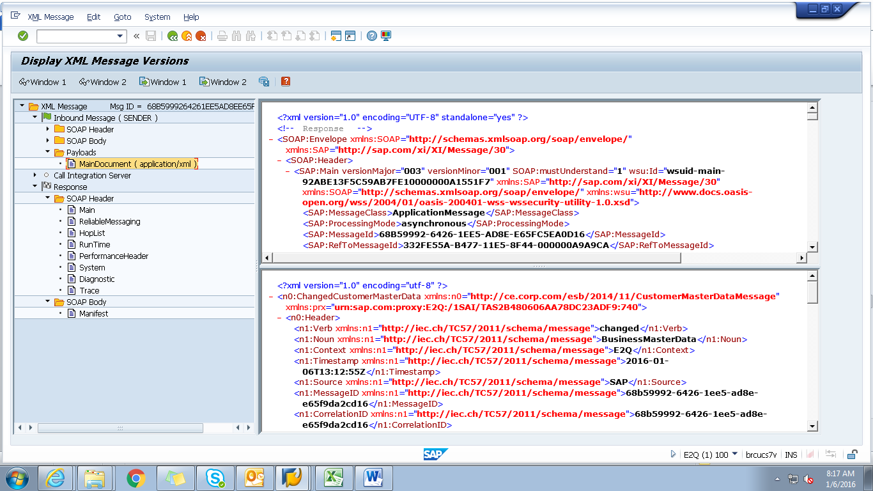

<?xml version="1.0" encoding="utf-8" ?>
- <n0:ChangedCustomerMasterData xmlns:n0="http://ce.corp.com/esb/2014/11/CustomerMasterDataMessage" xmlns:prx="urn:sap.com:proxy:E2Q:/1SAI/TAS2B480606AA78DC23ADF9:740">
- <n0:Header>
<n1:Verb xmlns:n1="http://iec.ch/TC57/2011/schema/message">changed</n1:Verb>
<n1:Noun xmlns:n1="http://iec.ch/TC57/2011/schema/message">BusinessMasterData</n1:Noun>
<n1:Context xmlns:n1="http://iec.ch/TC57/2011/schema/message">E2Q</n1:Context>
<n1:Timestamp xmlns:n1="http://iec.ch/TC57/2011/schema/message">2016-01-06T13:12:55Z</n1:Timestamp>
<n1:Source xmlns:n1="http://iec.ch/TC57/2011/schema/message">SAP</n1:Source>
<n1:MessageID xmlns:n1="http://iec.ch/TC57/2011/schema/message">68b59992-6426-1ee5-ad8e-e65f9da2cd16</n1:MessageID>
<n1:CorrelationID xmlns:n1="http://iec.ch/TC57/2011/schema/message">68b59992-6426-1ee5-ad8e-e65f9da2cd16</n1:CorrelationID>
- <n1:Property xmlns:n1="http://iec.ch/TC57/2011/schema/message">
<n1:Name>Stereotype</n1:Name>
<n1:Value>CustomerMasterData</n1:Value>
</n1:Property>
</n0:Header>
- <n0:Payload>
- <n2:CustomerMasterData xmlns:n2="http://ce.corp.com/esb/2014/11/CustomerMasterData#">
- <n2:Customer>
<n2:mRID>1000264909</n2:mRID>
<n2:name>JASONGREENLEAFTOMDPPTEST</n2:name>
- <n2:CustomerAccounts>
<n2:mRID>100047520844</n2:mRID>
<n2:createdDateTime>2009-10-28T04:00:00Z</n2:createdDateTime>
<n2:notificationByEmail>true</n2:notificationByEmail>
<n2:paymentTerm>CE21</n2:paymentTerm>
<n2:type>RES</n2:type>
- <n2:CustomerAgreements>
<n2:mRID>4013670271</n2:mRID>
<n2:accountDeterminationID>RT</n2:accountDeterminationID>
<n2:createdDateTime>2009-10-28T04:00:00Z</n2:createdDateTime>
<n2:division>ELECTRIC</n2:division>
<n2:rateCategory>RS_1000</n2:rateCategory>
<n2:startMonth>00</n2:startMonth>
- <n2:Installation>
<n2:mRID>5001966292</n2:mRID>
</n2:Installation>
- <n2:ServiceLocations>
- <n2:UsagePoints>
<n2:mRID>6002276609</n2:mRID>
</n2:UsagePoints>
</n2:ServiceLocations>
- <n2:validityInterval>
<n2:end>9999-12-31T23:59:59Z</n2:end>
<n2:start>2009-11-05T00:00:00Z</n2:start>
</n2:validityInterval>
</n2:CustomerAgreements>
</n2:CustomerAccounts>
- <n2:Indicators>
<n2:type>SENIOR</n2:type>
</n2:Indicators>
- <n2:Indicators>
<n2:type>DLA EXCLUSION</n2:type>
</n2:Indicators>
- <n2:Indicators>
<n2:type>DPP EXCLUSION</n2:type>
</n2:Indicators>
- <n2:Indicators>
<n2:type>DO NOT MARKET</n2:type>
</n2:Indicators>
- <n2:MainAddress>
- <n2:streetDetail>
<n2:buildingName>0024758872</n2:buildingName>
<n2:name>Silver Pkwy</n2:name>
<n2:number>15240</n2:number>
<n2:suiteNumber>Apt 208</n2:suiteNumber>
</n2:streetDetail>
- <n2:townDetail>
<n2:code>48430-3486</n2:code>
<n2:country>US</n2:country>
<n2:name>Fenton</n2:name>
<n2:stateOrProvince>MI</n2:stateOrProvince>
</n2:townDetail>
</n2:MainAddress>
- <n2:Persons>
<n2:firstName>JASON</n2:firstName>
<n2:lastName>GREENLEAFTOMDPPTEST</n2:lastName>
- <n2:electronicAddress>
<n2:email1>jason.greenleafdpptest4@gmail.</n2:email1>
</n2:electronicAddress>
- <n2:landlinePhone>
<n2:localNumber>987-654-3210-</n2:localNumber>
</n2:landlinePhone>
</n2:Persons>
</n2:Customer>
</n2:CustomerMasterData>
</n0:Payload>
</n0:ChangedCustomerMasterData>

